# Course Project Part 1-EXECUTIVE SUMMARY

November 13, 2022

Taran kumar

BIA-674 supply chain ANALYTICS

Stevens Institute of Technology – Fall 2022

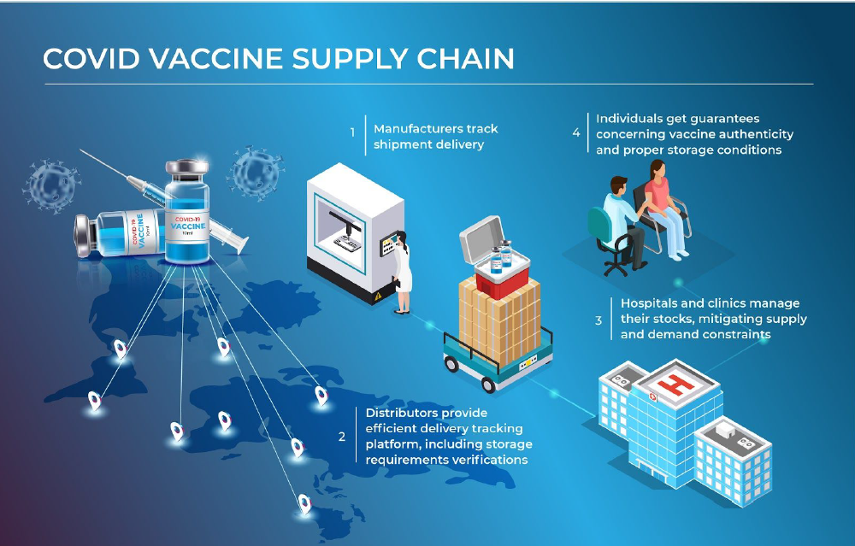

# Executive summary

The covid-19 pandemic is also known as the coronavirus pandemic. It is an ongoing global pandemic that started in December 2019. Mid-April 2020 was the rapid time when COVID was at its peak and it was first detected in Wuhan, China. Several million people were infected globally, and a hundred thousand people had died due to covid. Italy and China experienced the highest cases of covid, and their hospitals were flooded with patients, causing a major shortage of vital intensive-care materials. To reduce the cases and spread of covid, many governments-imposed lockdowns in their countries, and people were not allowed to go out of their homes. Due to government lockdowns supply chain and demand of important industries were disrupted including, retail, manufacturing, services, tourism, and disabling the global economy. Due to all these crises, many financial markets began collapsing and it was a kind of great depression for them. The government announced rescue packages to help people overcome the economic impact of the crisis.

Now, a global race had begun between the countries and companies for rapid production, discovery, and distribution of effective vaccines after the time when the government steered a trade-off between public health outcomes and economics. It was now a challenge for organizations of the supply chain to manufacture, administrate and distribute the vaccine to 7.6billion people to get herd Immunity. The actual challenge was the manufacturing distribution of the vaccine around the world. There was a shortage of minor components also as companies were short of time and supply but even then by November 2020, there was a different type of vaccine produced, the supply chain of these vaccines was having issues with a shortage of packaging of components and cold chain transit. The vaccine produced were predicted to be effective partially against infection and to resolve this issue it was important for the government to plan for flexibility in the manufacturing and distribution system and continue to invest in further development.

By March 2020, the COVID-19 global pandemic was declared by World Health Organization, and by Nov 2020, there was a faster development in vaccine production. Many unpredictable countries, organizations, research institutes, and companies were working together on it and helping each other as this was something that had affected the world at once.

A huge amount of money was being spent on research and development of a covid vaccine. Around, USD 200 million to USD 500 million was spent per vaccine and there was no restriction on research and development. Organizations were allowed to do as much testing and research as needed without any restriction on funding. The main aim for to produce a vaccine that can cure COVID-19 impact and later provide subsidized access to lower-income countries. BY end of 2021, the COVAX facility distributed around 2 billion among all participant countries no matter what income level they have. This facility was co-led by three organizations Gavi, CEPI, and WHO. US and Russia have outside formed this program. The US had its own initiative named Operation Warp Speed in which they allocated nearly $10 billion for vaccine development and manufacturing. Many organizations and countries were working to produce the vaccine that can help to overcome COVID-19 and Exhibit 3 shows the global vaccine portfolio by stage).

The vaccine development takes several years and involves three stages. Starting with research (exploratory phase 2-4years), then testing (pre-clinical & clinical trials), and then manufacturing. Moving forward there are three phases of a COVID clinical trial, the trials were increasing from the first phase to the third phase on different people. Much funding was spent to do multiple trials and the highest priority was given to COVID vaccines over everything else.

However, there were a lot of challenges, while doing the COVID-19 vaccination trial. The demonstration was difficult due to a lack of information on incident rates, variation in severity, and asymptomatic transmission, trial design The low attack rate meant that even with large-scale trials with tens of thousands of human subjects, only a small proportion of the subjects would eventually contract the virus and allow testing of the effectiveness of a vaccine candidate.

Not only this, there are politics and temptation rush also that causes tension. The US, China, and Russia release the vaccine into the market prematurely and this was due to an increase in their economic and political pressure. This thing was shaking the trust of people due to rush manufacturing and distribution by skirting time-consuming quality assurance protocols and safety checks.

Now, if we have a look at the research and studies, the global portfolio of COVID-19 consisted of a diversity of platforms from well-established to novel technologies not previously licensed with humans. Despite this diversity, there were some concerns over the politically motivated exclusion of certain candidates including China and Russia.

As the work was already started on the vaccination and first-generation vaccination was developed, now there were some challenges in developing second-generation vaccination. There was a consensus among experts that the vaccine released by 2020 or 2021 will only be affected partially and would not be suitable for global distribution and suggested the development of second-generation vaccination which was expected to be introduced in September 2023 till that time masks and distance would likely to be continued. For this development, the continuous investment would be needed, and it should be open to new entrants.

Manufacturing was also not easy at all and was a big investment. Manufacturing was typically created after it is proven effective in phase III trials. Without public financing support, companies were underinvesting so governments in the US, UK, EU, and COVAX made advance purchase commitments and provided grants to undertake costly investments for promising vaccine candidates under clinical trials.

Traditionally, it takes nearly half a decade to manufacture capacity for a safe and effective vaccine, two to three years to build its plant, and accordingly more to produce in large quantities. Most vaccine production was seasonal and vaccine developers were finding a niche market for vaccine diseases like HPV. Vaccine manufacturing involves many complex biological processes that are time-consuming to ensure quality control, product effectiveness, and safety. Testing and quality assurance takes up around 70% of the production line. The production process consists principally of 2 stages: (i) drug substance and (ii) drug product manufacturer which involved formulating, packaging, and storing the vaccine content in preparation for delivery.

As discussed above there is a global portfolio of vaccines, it includes a diversity of technology platforms and has a variety of manufacturing requirements and processes. Portfolio also includes candidates that use novel, untried technologies like DNA and messenger RNA vaccine that are never approved before for human care. These require entirely new production capacity as their manufacturing requirements are different. Different candidates like Pfizer and Moderna use different technologies in their trials and have their own challenges.

Pre-covid the supply chain of vaccine production capacity was based on several parameters such as volume of demand, cost of manufacturing, and policy incentives. Countries like China, Brazil, and India had invested a lot in serving their local demand. Vaccine production has a complex nature and needs an experienced workforce along with strong regulatory support. There were political tensions also before the pandemic such as a trade war between US and China which are complicated location decisions for vaccination production. Moreover, Countries like Hong-Kong and Singapore were able to export it to lower-income countries due to their lower population.

It is important to understand that building manufacturing capacity for COVID-19 was very costly and it was being used to mitigate the risk to the global economy in short term but what about the long term? Much of the capacity will go unused after the crisis abated. Direct investment and advance purchases by some countries risked leaving fewer vaccine supplies for equitable distribution. Equitable distribution was very important because people with high-risk medical conditions were at the highest risk of worst symptoms of Covid mainly workers, healthcare staff, and people who were over 65. Therefore, the National Academics of Sciences and Engineering and Medicine recommended the US Department of Health and Human Services implement four-phased equitable allocations.

A further challenge was raw material and component supply. There was a shortage of packaging material and ingredients and vaccine manufacturing efforts proved slower through the fall of 2020. Companies like Pfizer and Moderna announced slower growth and production due to a shortage in components and manufacturing equipment supplies. There were actions taken to mitigate this shortage that included global cooperation and coordination, horizontal collaboration across competing developers and manufacturers, and speculative manufacturing.

There was also a scaling risk as companies invested in developing manufacturing in parallel with clinical trials but mass production was harder than expected. Companies that decided to produce 100million vaccines ended up producing like 50million only. One of the major reasons for this was also that rushing to meet demand was resulting in poor quality and safety compromises which were then resulting in recalls of vaccination.

Having all these issues and the availability of funds, experts predicted that only 46% of vaccine candidate was reaching phase III trials and 16% chance of success from pre-clinical trials. Not only this, the distribution of vaccination was also a major issue. Once the vaccination was authorized or licensed for use and production it was a great challenge to distribute it to a global population of 7.8 billion people that includes, including transportation and delivery issues.

To solve the issue of distribution the countries and organizations emerged two camps around distribution: 1) multilateral cooperation and 2) bilateral agreements between a country and a drug company. Other countries like the USA announced their own approach to distribution.

This was not it and there were many other issues to such an important challenge of growing vaccines was the hesitation of people to being vaccinated. For example, In the US half of the people nearly (42.4%) shows hesitation towards vaccination, 10% were those who didn’t intend to be vaccinated and 32% were indecisive. There were many reasons for this but majorly they were concerned about vaccines specifically, anti-vaccine beliefs, and generally, lack of trust was a major setback.

Another challenge was the transportation of vaccines because vaccines require a certain temperature and controlling temperature, as well as logistics, was a huge issue as reported by WHO. Most importantly, the major issue was that each vaccine was requiring different temperature capacitates. The diversity of requirements of vaccine temperature created significant challenges in distribution and complicated infrastructure requirements. Also, the shelf life of Covid vaccine was 5 days in standard refrigeration once they are removed from insulated boxes and there were many developing countries lacking infrastructure for cold chain distribution. This is the reason UPS announced in the US and Germany to construct cold storage facilities each with 600 freezers able to accommodate 48,000 vials of the vaccine in insulated boxes of dry ice that would maintain the proper temperature for up to 96 hours. These facilities enabled overnight delivery to any part of the world with monitoring temperature devices on trucks that can provide real-time temperature tracking.   
Considering these challenges proper planning was an important step in the supply chain with billions of vaccine doses needed and fear of significant losses in cold transit, even seemingly minor operational decisions related to batching and allocating vaccine doses could critically affect the distribution and as well as, lives. Going forward by Nov 2020, Covid-19 vaccine development saw major developments but still some vaccine candidates face development and manufacturing risk.